Principal Investigator: Maggie Gaddis, M.S., Ph.D.
Colorado Native Plant Society, ExecutiveDirector@CoNPS.org, 719-314-5177 Executive Summary
In an effort to increase native plant applications and success in wildland and horticultural settings, we conducted a study in which we propagated and reared four forb and four grass species in a crossed design that measured plant growth and survival in 1) three types of soil (peat moss, a mineral and compost mix, and native garden soil), 2) with and without fertilization, and 3) with three planting dates (July 11, August 14, September 11). We coordinated three volunteer events to install the grown plant material in a restoration site on North Table Mountain Park. We coordinated biweekly ecological monitoring events to measure the success of these plants in the field. We engaged 114 volunteer community scientists to conduct monitoring protocols. Three University of Colorado - Boulder geography student interns and two CoNPS interns are assisting in the data digitization and analysis.
Our results indicate that plant species had variable survival rates compared to each other. Forb survival rates were higher than grass survival rates except for Bouteloua gracilis, a top performer in the study. Across all cross-comparisons of soil, fertilization, and planting date, plants grown in the mineral compost mix (MC) had higher survival rates than those grown in peat or garden soil (S3). Fertilized plants had greater survival rates than unfertilized plants. September-planted individuals currently have the highest survival rates to date. We will monitor the plots again in 2026 to ascertain which plants survived the winter.
Abstract
In the Jefferson County Parks & Open Space (JCPOS) native plant survival study, eight native species were grown and planted in a restoration site on North Table Mountain Park. The plants were grown in three soil types, including peat moss, a crushed granite (mineral) and compost mix, and native garden soil. Half of the plants were fertilized during the rearing phase. Plants were installed in the field in July, August, and September. Plants grown in the mineral and compost mix had the greatest survival rates, while peat moss-grown plants had the lowest survival rates across treatment levels. Native garden soil-grown plants had intermediate survival rates. Across all treatment levels, fertilized plants had the greatest survival rates. To date, plants installed in September have the highest survival rates. In our preliminary analysis of these data, all cross comparisons of treatment levels and plant survival indicate that native plants grown in mineral and compost mix have the greatest survival rates.

Literature Review
While there are significant literature contributions supporting native plant success in wildland restoration conditions, more work is needed to describe best management practices for high elevation revegetation using native plants, especially in landscapes facing intense recreational pressure and threats of wildfire and drought (Dreesen & Harrington, 1997; Gaddis, 2018; Meyer, 2006; Von Bargen, et al, 1988). We wanted to understand which native species are 1) representative of the local wild flora, and 2) easy to manage in smaller growing operations that might be implemented by municipal, county, and open space managers to facilitate local project needs, and 3) whether peat free soil media can be used in propagation efforts to reduce the total carbon footprint of growing operations. There are only a few nurseries in the western United States that can handle seed increase on a large scale and none in Colorado, other than the USFS Meeker Plant Materials Center, which can not possibly serve all the needs of Colorado communities and landscapes. Therefore, local land managers need to learn how to grow plants for their own restoration activities.
Given our tremendous success in the Pikes Peak Region with methods that provide a priori conclusions upon which this study is built, we were confident that our partnership with JCPOS would extend the impact of our work to increase native plants and habitats in Colorado, for the survival and well-being of humans and wildlife alike. In addition to our horticultural successes, we found that these methods greatly reduced the operational costs of the Colorado Springs (COS) city horticulture department, specifically the cost of soil and seed used in propagation efforts. We utilized more square footage in the horticultural complex while reducing electrical and heating costs by overwintering natives outdoors and in cold houses. We expect similar cost-saving results could be achieved by JCPOS.

Research Objective: Investigate native plant survival and growth rates across soil types, planting dates, and fertilization treatment levels.
Hypotheses
Hypothesis 1: Native seeds have variable germination rates that are regulated by environmental conditions.
Null Hypothesis 1: Environmental conditions do not affect seed germination rates. Hypothesis 2: There is a difference in plant growth due to soil type.
Null Hypothesis 2: There is no difference in plant growth due to soil type.
Hypothesis 4: There is a difference in plant growth with fertilization.
Null Hypothesis 4: There is no difference in plant growth with fertilization.
Hypothesis 5: There is a difference in plant growth due to planting date.
Null Hypothesis 5: There is no difference in plant growth due to planting date.

Methods
We planted over 2000 seeds of four native forb species and four native grass species (Table 1). All seed, except Pascopyrum smithii, was hand-collected on JCPOS properties. The Pascopyrum smithii came from a Boulder County seed increase. You can learn more about these species in this slideshow. We established a crossed design with three soil treatments, three planting dates, and two fertilization regimes, fertilization and no fertilization. We worked with JCPOS to select the species from the JCPOS seed bank. All seeds used were native to JCPOS and collected by volunteers or staff on other JCPOS volunteer events prior to 2025.
Of note, we removed Symphyotrichum ericoides (SYER) because, as it grew, we observed two leaf forms and, when it flowered, three flower types, suggesting that this Symphyotrichum may have undergone hybridization. We eventually keyed out a flowering specimen to S. falcatum and JCPOS staff keyed out other specimens to S. laeve. Interestingly, after removing this species from the study, lots of Symphyotrichum started appearing in our plots, making it impossible to know which ones we planted.

Table 1. Eight native species were used in this study.
Species Code Key
ACMI - Achillea millefolium common yarrow
ARLU - Artemisia ludoviciana white mountain sage/ silver wormwood
HEVI - Heterotheca villosa hairy goldenaster
SYER - Symphyotrichum ericoides white aster
BOGR - Bouteloua gracilis blue grama
HECO - Hesperostipa comata needle and thread grass
NAVI - Nassella viridula green needle
PASM - Pascopyrum smithii western wheatgrass
The first phase of this research occurred in the Colorado Springs city greenhouses. JCPOS supplied us with their chosen planting vessels, SC10s. We established one SC10 tray per soil type and species. Each SC10 tray held 98 plants. We planted 98 seeds per forb species in two soil types, for a total of 184 seeds per species and 736 forb seeds in total. We planted approximately 10 seeds per grass cell to produce a plug for planting. We planted the seed on 5-1-2025 and 5-2-2025.
These trays were watered twice per day with a mist spray that contained fertilizer. All the plants received fertilization during the germination phase because there was no way to standardize the watering in the greenhouse and also avoid fertilization.
Once the plants went outside for hardening off, the regime of fertilization or no fertilization began.
During the germination period, while the seedlings were in the COS city greenhouses, 12-6-6 natural liquid fertilizer was applied via the misting system at a rate of 16oz/500 gallons, corresponding to a dilution rate of 0.03oz/gallon. During the hardening-off period, when the plants were outside but not yet at the field site, we applied a 12-6-6 natural liquid fertilizer at a rate of 0.04oz/gallon once per week using a pump sprayer.
We measured germination rates weekly until June 1. We calculated germination rates on June 1, 2025. We then moved the plants outdoors to acclimate them and initiated the fertilization regimen. We fertilized half of the plants using a pump sprayer to mimic the foliar application applied in the greenhouse. The other half of the plants received only water.
Once the plants were outdoors, we watered with an overhead, oscillating sprinkler daily for one week, then every other day for week two, and then every three days for week three. We watered for 45 minutes each time. In week three, what had been a very wet season ended abruptly. Unfortunately, this conflicted with our water-reduction schedule. We lost many plants in mid-June because temperatures reached 100°F and rainfall nearly stopped.
We planted any additional plants from the germination effort in 3” pots and native garden soil. We never intended for these plants to enter the study environment, calling them the “insurance plan.” We intended to give them to JCPOS, as the request was to return all seed and plant material that was not used in the study design. When the originally germinated plants experienced damage during the hardening-off process, we decided, in consultation with JCPOS staff, to transplant them into native garden soil to maintain the total number of plants for the study. This was an unfortunate outcome as it complicated the treatment levels. However, it was very interesting to observe the results discussed below. We stopped planting garden soil plants in August because we did not have enough prepared plots to conduct another round of planting with three soil types.
We had a volunteer event at the Colorado Springs horticulture complex on July 1, during which we replanted a half set of seeds in SC10s for a total of 49 seeds per forb species, one seed per cell, per soil treatment. We planted approximately 10 seeds per cell per soil treatment for grass species, for a total of approximately 490 seeds per grass species. These plants were installed in the September 11 planting. As such, these plants were set out at the same age as the original planting, approximately two months after seeding. Furthermore, they spent one month in the greenhouse and one month outdoors before being planted in the study plots.
The crossed design investigated two amendment treatments, 1) fertilizer, and 2) no fertilizer, in three soil types, 1) peat-based greenhouse potting soil commonly used in planting operations, 2) a proprietary mix of crushed granite (mineral) and compost made from Colorado Springs municipal horticultural waste, and 3) native garden soil. One soil chemistry study has already been completed (Houghton, 2024), which indicated that the chemical composition of the mineral and compost mix was more similar to native soils than to the commercial nursery mix. Follow-up research indicated that native species could germinate across all three soil types (Rose, 2024).
The three soils employed were mineral-compost (MC), native garden soil (S3) and peat. We used Fertilome Ultimate, a ready-to-use potting mix, as the peat medium. This is a Lambert product composed of 5-15% perlite and 85-95% sphagnum peat moss.
Garden soil (S3) was harvested from the ground in a residential context in Colorado Springs. Previously, subsoil had been excavated from another garden area and added to this site. This is the location from which we harvest soil to mimic the mineral-compost (MC) mix used at the COS greenhouses, since it is heavy in mineral content. We mixed this with homemade compost composed primarily of chicken refuse, pine shavings, food scraps, and garden waste.
The MC soil is composed of Cimarron Breeze mineral product purchased at C&C Sand and Stone. The mineral base is mined from the Menzer quarry south of Colorado Springs. Cimarron breeze is composed of mineral particles ⅜” and smaller. The compost is made at the city horticultural complex. It is made from horticultural waste, including plant material. It contains some peat moss as the annual plant operations of the horticultural department are grown in peat moss, as they are purchased rather than grown on site from seeds.
We established 12 common garden plots on JCPOS property on North Table Mountain Park, with the guidance and assistance of JCPOS staff. To reduce the non-native plant density in the plots, JCPOS staff sprayed the 12 common garden plots with a 3% solution of Ranger Pro. Application took place 4/8/2025. On each planting day, we prepared the plots by hand-pulling any non-native species present, including encroaching Bromus inermis. We did not continue to weed the plots on subsequent monitoring visits.
We planted the first set on July 10, 2025. We measured plant growth parameters (germination, plant height, number of stems) biweekly from July 2025 to October 2025, recruiting volunteers through the JCPOS Offero site and the CoNPS website calendar. We calendared the events in Offero so volunteers could sign the JCPOS waiver. We then cross-linked those events into the CoNPS calendar. We planted out during three volunteer events (July 10, August 14, and September 11, 2025). On the July planting date, we planted all species in peat and S3. We also planted BOGR in MC, the only species with a sufficiently large sample size that survived the hardening-off stage. On the August planting date, we planted all species in MC, peat, and S3. On the September planting date, we planted all species in MC and peat. We did not plant any species in S3 because we had no additional plots to allocate treatments. The volunteer demographics were a mix of JCPOS and CoNPS volunteers.
In biweekly monitoring events calendared in the same way described above for the planting dates, we measured plant growth parameters (presence, plant height, number of stems). We will conduct an additional monitoring event in the spring of 2026 to ascertain winter survival. We engaged 114 volunteers through our calendared events.
We also engaged four interns who helped run the events, conduct post-volunteer monitoring, digitize the datasheets, and analyze the data. Three interns were recruited from our CU Boulder Geography Department internship program. The two other interns were recruited through the volunteer events. While our data collection is complete and our preliminary data analysis is presented in this draft report, interns are still analyzing these data using R. Another intern will prepare a map of the study site. These are not yet complete because the interns are in a semester-long program, and their projects are not due until the end of the semester. We will incorporate these efforts into our final report.
We collected soil from each field plot for chemical analysis using the collection protocol provided by the CSU Soil Testing Laboratory. We sent these samples to the CSU Soil Testing Laboratory, along with a peat sample, an MC sample, and an S3 soil sample. We ordered a complete soil test and a texture analysis.
Soil pH primarily affects nutrient availability to plants. pH is a measure of H⁺ ion activity in the soil solution. The higher the concentration of free H⁺ ions, the more acidic the soil. In acidic soils, excess H⁺ competes with nutrient cations such as Mg²⁺, K⁺, and Ca²⁺ for exchange sites on soil particles. When H⁺ displaces these nutrients, they are released into the soil solution, where they may be leached and become less available to plants (Whiting et al., 2002; Franzmeier et al., 2016). Colorado soils generally range from neutral to basic. Acidic soils are more common in humid climates. As shown in the figure, in more basic soils, nutrients such as zinc and iron are commonly in short supply (Whiting et al., 2002).
In this study, pH matters for two main reasons. Native plants evolve with their local soil chemistry. If seedlings are raised in a substrate that does not reflect the soil in which they evolved (e.g., acidic peat-based greenhouse mixes), they may experience stress upon transplantation. If the site pH is not within a species’ tolerance range, seedling survival may decline. Fortunately, soil pH can be modified with amendments, at least temporarily, to support seedling establishment.
Soluble salts (Electrical Conductivity—EC) form naturally as water weathers rocks and minerals. Many salts are essential for plant function, but high concentrations can inhibit water uptake. In Colorado’s arid climate, salts tend to accumulate because less rainfall washes them deeper into the soil profile. Native plants are generally adapted to this, but salt sensitivity varies with growth stage. Seedlings are usually the least tolerant to excess soluble salts. (Morden et al., 1986).
Lowering salt content in a restoration setting is challenging; the most effective method is water leaching, which is not always feasible. For this study, knowing the EC (soluble salts) gives us a baseline and helps identify: 1) whether there is excess soluble salt at any of the plots, which may affect seedling survival 2) which species are salt-tolerant, and 3) whether planting should align with seasons of higher precipitation.
Organic matter plays a major role in determining soil structure. It acts like a “glue,” helping soil particles form aggregates. These aggregates regulate water movement, improve drainage in dense soils, and help sandy soils hold moisture. Organic matter also retains far more water and nutrients than mineral particles do. Soils low in OM tend to have lower fertility and dry out more quickly, factors that directly affect seedling survival in restoration contexts. (USDA, Role of organic matter).
The “lime index” (or buffer pH) reflects a soil's resistance to changes in pH—its buffering capacity (Franzmeier et al., 2016).
A low lime index indicates that the soil will change pH easily.
A high lime index indicates that the soil is more resistant to change.
This measurement is most often used in acidic soils where lime is added to raise the pH. For our study, lime indices help us understand how quickly pH-adjusting amendments would take effect, if needed.
CEC measures a soil's capacity to hold and exchange nutrients. Most soil particles carry a negative charge, and many nutrient ions are positively charged (K⁺, Ca²⁺, Mg²⁺). These nutrients temporarily adsorb to the soil surface and can be exchanged for H⁺ ions released by plant roots. The greater the soil's negative charge and surface area (common in soils with high clay or organic matter content), the higher its CEC (Franzmeier et al., 2016). In this study, higher CEC indicates soils that can hold more nutrients for longer. Because seedlings across all soil types respond positively to fertilization, CEC helps explain how much fertilizer the soil can retain before nutrients leach.
Nitrate (NO3), Phosphorus (P), Potassium (K), Calcium (Ca), Magnesium (Mg), and Sulfate-Sulfur(SO4-S) are essential plant macronutrients. Limited amounts of any of these nutrients can restrict plant growth and functioning (Taiz et al., 2023).
Sodium (Na), Zinc (Zn), Iron (Fe), Manganese (Mn), Copper (Cu) are essential plant micronutrients: micro not meaning unimportant. Micronutrients are just as essential to plant function, but plants use smaller amounts of these nutrients (Taiz et al., 2023).
Results
Germination Results
We measured germination rate as presence/absence per cell. Since only one seed was planted per forb, the presence or absence of a seed was recorded. Since we planted approximately 10 seeds per cell of grass species, the presence of any single individual that germinated in the cell. Germination rates across all species and soil types were high. This is firstly a testament to the JCPOS seed collection efforts, as clearly the seed had been collected at an appropriate time of seed maturity. Germination rates were slightly higher in peat moss than in mineral compost mix, with the exception of Hesperostipa comata (HECO) and Nasella viridula (NAVI) (Figure 1).
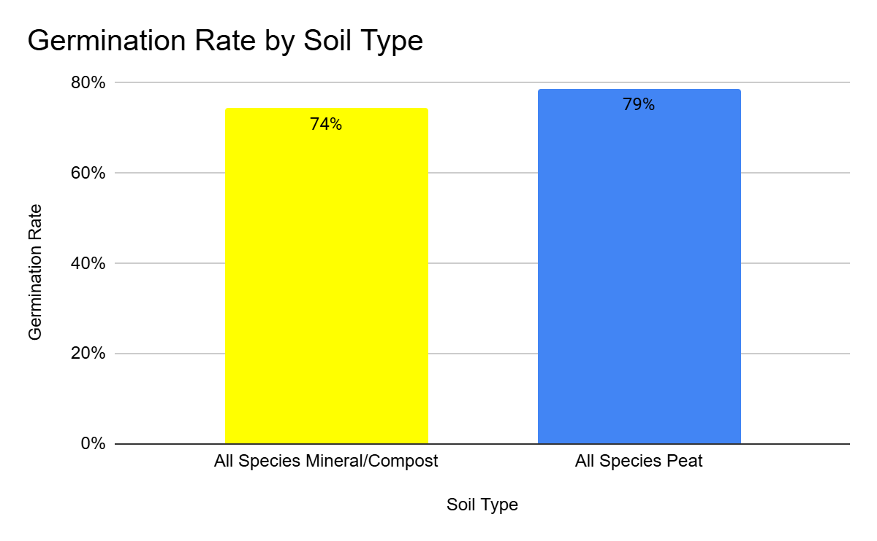
Figure 1. All species germinated in peat had an average germination rate of 79% and all species germinated in mineral compost mix had an average germination rate of 74%.
Germination rates were lowest for Achillea millifolium (ACMI) and Hesperostipa comata (HECO). Artemisia ludoviciana (ARLU), Heterotheca villosa (HEVI), and Symphyotrichum ericoides (SYER) had the highest germination rates (Figure 2). Overall, the germination rates between peat and MC were very similar.
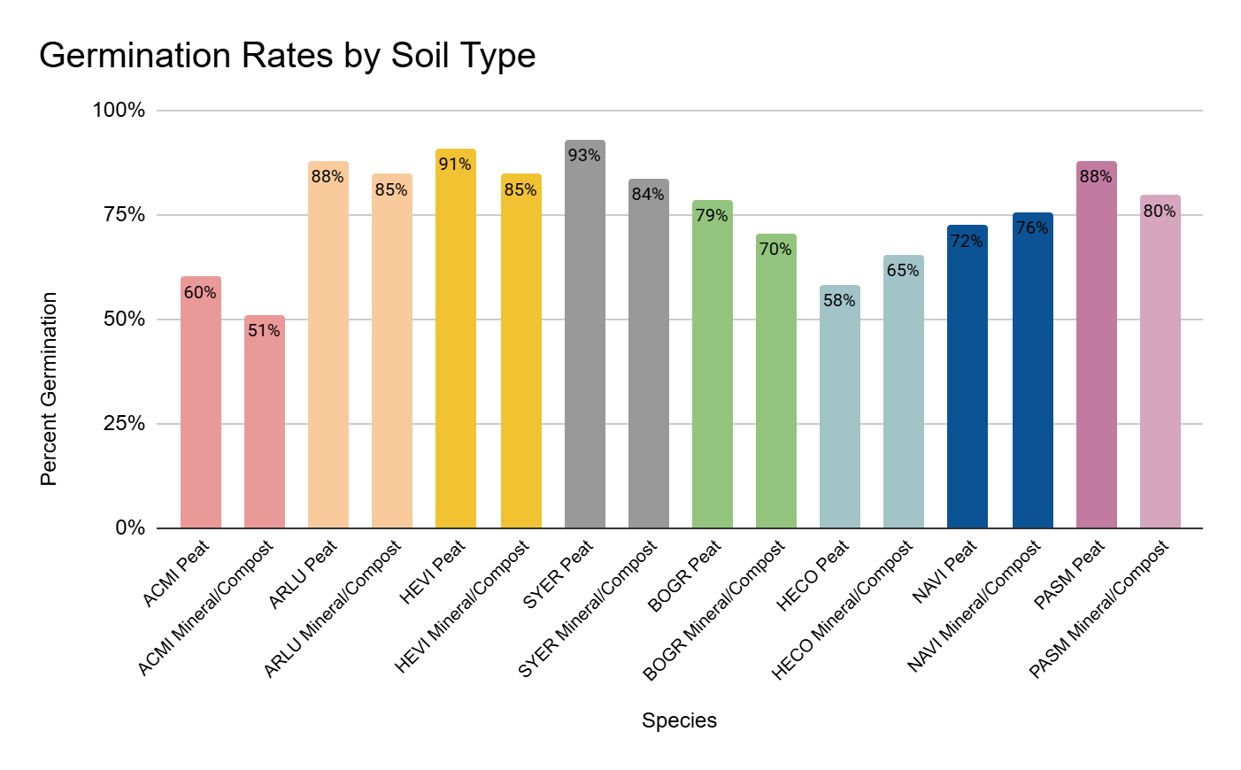
Figure 2. Germination rates per species across soil types showed higher germination in peat for six of the eight species.
Field Results
The average survival across all species was lowest for the July planting date (48%) and highest for the September planting date (72%). The August planting date had an intermediate average survival rate (62%) (Figure 3).
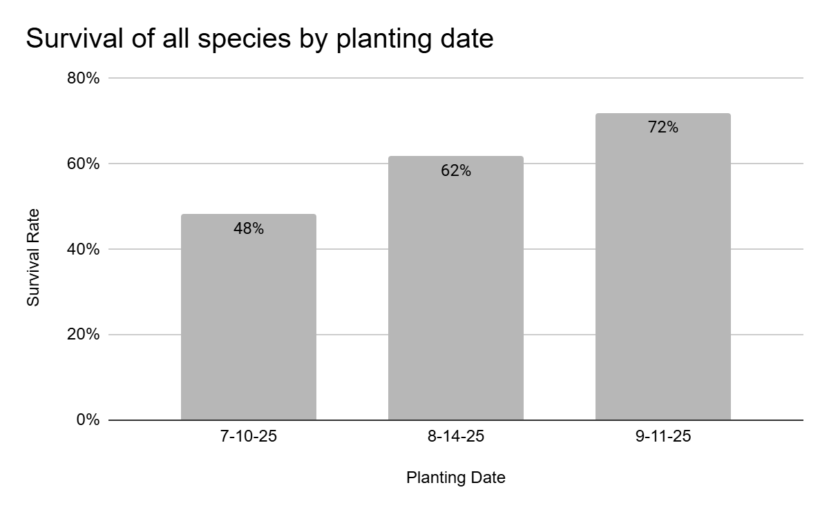
Figure 3. Species were planted on three dates throughout the summer of 2025.
When we examine the data parsed by planting date and soil type, we see a more complex pattern. The plants that survived the least were clearly ones planted in the peat and garden soil plots. Plants in the mineral compost mix had impressive survival rates in both July (88%) and September (81%) as compared to average survival rates in peat in July (47%) and in September (74%), and in garden soil in July (46%) and August (62%) (Figure 4).
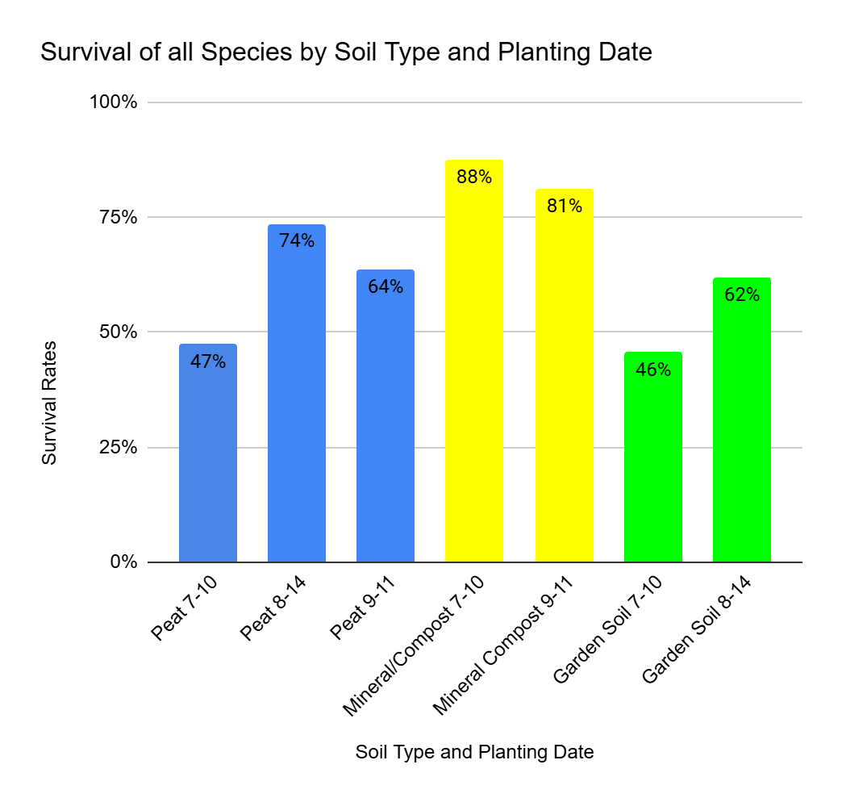
Figure 4. Plants in the mineral compost mix showed opposite average survival rate by planting date than those observed in peat and garden soil.
When we compared the survival of all species on all planting dates to their soil types, we found one of the most stunning results of the study. The average survival rate of all species in mineral compost soil was 79% (Figure 5). In peat moss, all species average survival rate was 53%. Native garden soil resulted in an intermediate average survival rate of 71%.
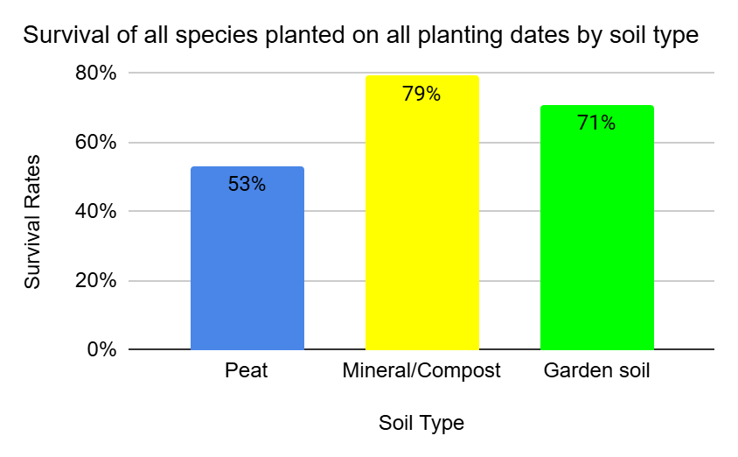
Figure 5. Average survival was highest in the mineral and compost mix.
When we examined a more nuanced view of individual species by soil type, we observed the same trend across species (Figure 6). The only clear exception was Artemisia ludoviciana (ARLU), which had a higher average survival rate in garden soil (78%) than in mineral compost mix (67%) or peat (67%). Pascopyrum smithii (PASM) had nearly identical average survival rates in mineral compost mix (47%) and peat (48%). A remarkable result was 100% average survival in Heterotheca villosa (HEVI) in mineral compost mix. The most poorly performing species was Nassella viridula (NAVI) in peat (11%).
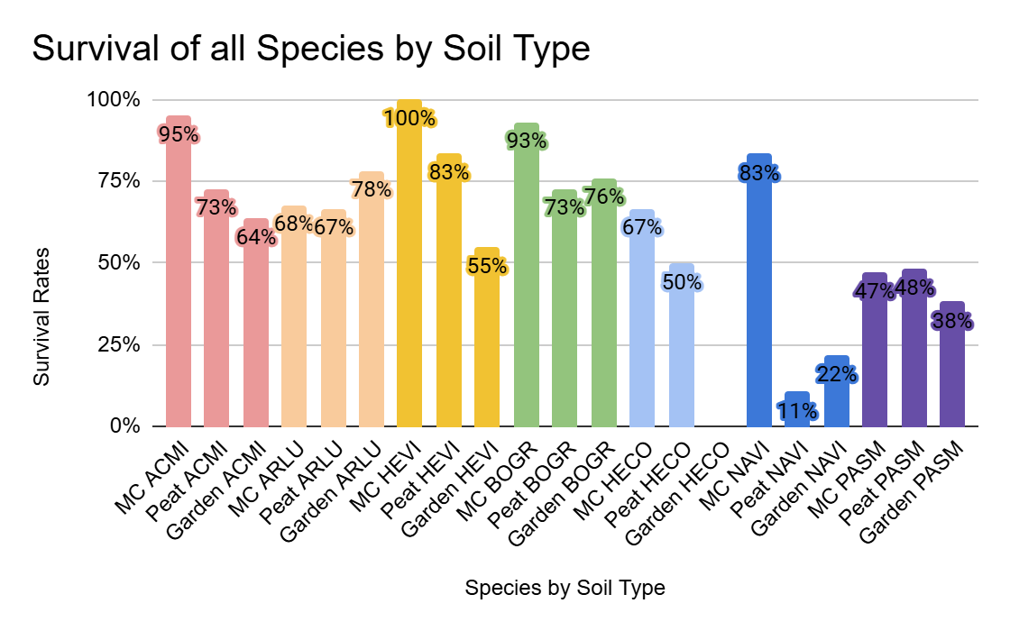
Figure 6. Most species had the greatest average survival rate in mineral compost mix.
When the data is parsed based on fertilization regime, we found that fertilization had a positive effect on all soil treatments (Figure 7). We observed the same trend when examining fertilization by soil type. In peat, fertilization resulted in an average survival rate of 58%, compared with 48% in unfertilized plots. In garden soil, fertilization resulted in an average survival rate of 65%, compared with 42% in unfertilized garden soil. In the mineral compost mix, the effect of fertilization was minimal, with 80% survival in fertilized plots and 79% in unfertilized plots (Figure 8).
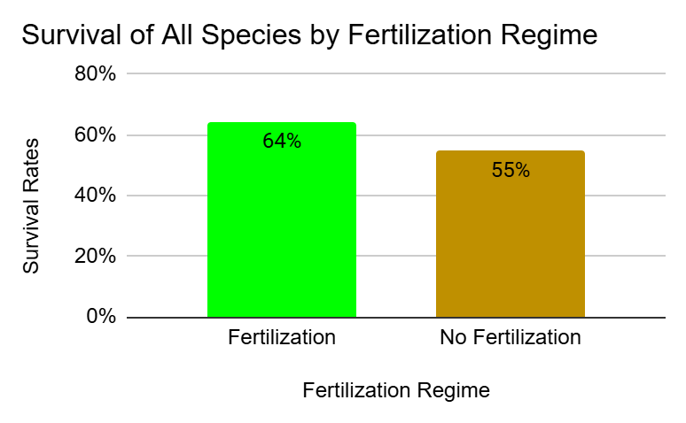
Figure 7. When all species were aggregated by fertilization regime, average survival was higher among individuals fertilized throughout the hardening-off period.
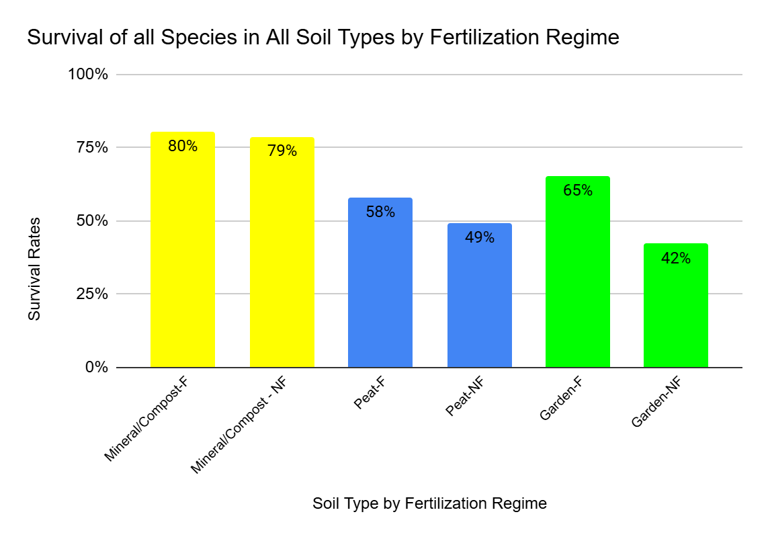
Figure 8. When we compared fertilization to soil type, we found that the positive trend of fertilization was consistent across soil types.
Finally, regardless of planting date, soil type, or fertilization treatments, the chosen species showed variable average survival rates (Figure 9). Furthermore, forbs as a group were more successful than grasses (Figure 10). The forb species had an average survival rate of 70-74%. Grasses had an average survival rate of 28-79%. The substantial variation in survival across grass species and within species across treatments raises questions about the reliability of our grass data. As noted, it was very challenging to find the grasses, especially with the encroaching non-native Bromus inermis.
Figure 9. Forb species performed better than grasses, with the exception of Bouteloua gracilis which was the top performer in the study.

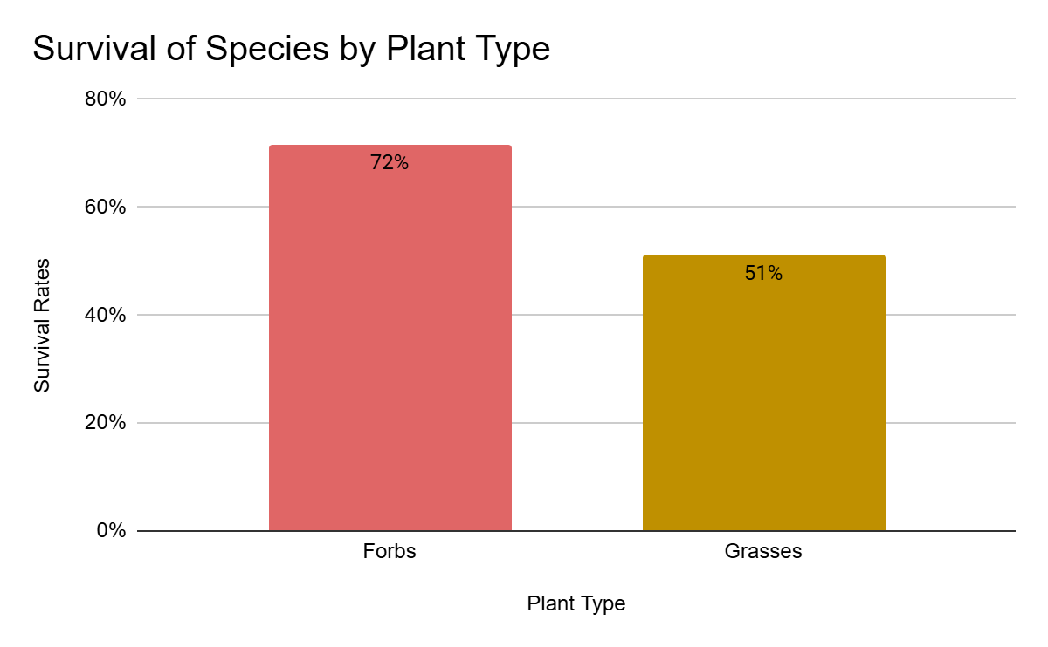
Figure 10. Forbs had an average survival rate of 72% while grasses had an average survival rate of 51%.
Data Analysis
We ran Analysis of Variance (ANOVA) tests in R Studio. ANOVA tests compare variation in survival rate within and across variables. We ran all possible combinations of species, plant date, soil type, and fertilization. Across all combinations of variables, we identified only three that showed statistically significant variation among groups: species comparisons, species and fertilization, and soil type and species. ​We used Tukey's Honestly Significant Difference (HSD) test to determine which pairs of variables had statistically significant differences in their means.​
The ANOVA results indicate a significant effect of species on survival (F = 4.581, p = 0.000817). The variation among group means (differences between species) exceeds the variation within groups (natural variation within each species). According to Tukey's test, ACMI, ARLU, BOGR, and HEVI are not statistically different in survival rate, whereas NAVI differs significantly from the others.
The ANOVA results indicate a significant effect of species and soil type on survival (F = 2.481, p = 0.00771). The Tukey test indicates that MC_BOGR differs statistically from peat NAVI. The survival rates of all other groups are not statistically different from one another.
The ANOVA results indicate a significant effect of species and fertilization on survival (F = 4.581, p < 0.000817). Tukey test results suggest BOGR_F and BOGR_NF are statistically similar in terms of survival rate, they are all statistically different from NAVI_F. All other groups' survival rates are not statistically different from those of any other species.
The dataset and graphs are available here.
Soil Analysis
The average pH was 8.3 for MC, 7.0 for S3, 6.0 for peat, and 7.0 for the native field plot soil. The average soluble salts (EC) were 0.0 mmho/cm for MC, 0.1 mmho/cm for S3, and 0.01 mmho/cm for peat. The native field plot soil EC was 0.1 mS/cm. The average organic matter content (OM) was 2.3% for MC, 5.1% for S3, and 4.8% for the native field plot soil. There was no excess lime in any soil type. The Cation Exchange Capacity (CEC) for MC was 10 meq/100g, and for SC it was 16 meq/100g. The native field plot soil CEC was 27.3 meq/100g.
Macronutrients measured in MC soil were nitrate (<1 ppm), phosphorus (63 ppm), potassium (310 ppm), calcium (1288 ppm), magnesium (310 ppm), and sulfate-sulfur (3 ppm). In S3, macronutrients were nitrate (9 ppm), phosphorus (92 ppm), potassium (586 ppm), calcium (2394 ppm), magnesium (325 ppm), and sulfate-sulfur (6 ppm). In native field plot soils, macronutrients were measured and averaged as nitrate (5.4 ppm), phosphorus (10.6 ppm), potassium (713.5 ppm), calcium (3931.2 ppm), magnesium (678.3 ppm), and sulfate-sulfur (3.1 ppm). We did not measure macronutrients in peat because it is a soil medium that is not yet decomposed. Therefore, the macronutrients are not yet available for plant growth.
Micronutrients measured in the MC soil were sodium (81 ppm), zinc (4.3 ppm), iron (24.7 ppm), and manganese (3.6 ppm). In the S3 soil, micronutrients measured were sodium (22 ppm), zinc (47.5 ppm), iron (42.8 ppm), and manganese (6.5 ppm). In native field plots, micronutrients measured and averaged were sodium (22.7 ppm), zinc (24.0 ppm), iron (98.1 ppm), and manganese (24.0 ppm).

Soil type | pH | EC  mmho/cm | OM  % | Nitrate-N  ppm | P  ppm | K  ppm | Ca  ppm | Mg  ppm | Na  ppm
field plots averaged | 7.0 | 0.1 | 4.8 | 5.4 | 10.6 | 713.5 | 3931.2 | 678.3 | 22.7
MC | 8.3 | 0.0 | 2.3 | <1 | 63 | 310 | 1288 | 310 | 81
S3 | 7.2 | 0.1 | 5.1 | 9 | 92 | 586 | 2394 | 325 | 22
Peat | 6.0 | 0.01

Soil Type | CEC  meq/100g | S  ppm | Zn  ppm | Fe  ppm | Mn  ppm | Cu  ppm
Field plots averaged | 27.3 | 3.1 | 24.0 | 98.1 | 24.0 | 4.2
MC | 10 | 37 | 4.3 | 24.7 | 3.6 | 1.1
S3 | 16 | 6 | 47.5 | 42.8 | 6.5 | 1.8
Peat |  |  | 28 | 3441 | 74 | 10

Soil type | % Sand | % Silt | % Clay | Texture by Hydrometer
field sites averaged | 59.1 | 16.0 | 24.8 | Sandy clay loam
MC | 75 | 13 | 13 | Sandy Loam
S3 | 68 | 18 | 14 | Sandy Loam

Discussion
Germination Results
The germination rates were high throughout the study (Figure 1). This is likely due to the highly controlled environment of the Colorado Springs city greenhouse. In some cases, we surmised that some of the ungerminated SC10 pots were not misted adequately. Ideally, we would have rotated the trays; however, their immense weight precluded this. Instead, we adjusted the mist spray position slightly each time we measured to ensure that every cell was adequately watered. In retrospect, we should have set up the trays so they were half peat cells and half mineral compost cells, allowing us to lift them more easily and rotate them on the bench.
When we compared germination rates across species and soil types, we found that germination was slightly higher in peat moss (Figure 2). We hypothesize that the increased water-holding capacity of peat moss may explain this result. It is also important to consider seed design. Soil media should not influence germination rates, since all biotic needs of the embryo are supplied by the seed environment itself. Abiotic factors such as adequate water and warm temperature are signals that break seed dormancy. The soil itself does not provide any enrichment until the seed germinates and the plants begin to grow.
We found that germination rates were lower in the July planting. We assume that by July, the greenhouse is too hot to provide a conducive environment for seeding. Another possibility is that the environmental signals for the plant are off. By July 1, past the summer solstice, the days are already getting shorter, which typically signals to plants that they should begin flowering rather than break dormancy. Typically, the Colorado Springs horticulture department suspends seeding during the hot summer months. Although this is an anecdotal observation for now, future research might investigate the success of germinating native seeds at different times of year.
Field Results
The planting date affected the plant material (Figure 3). After a wet, cool spring, we experienced a dry, hot midsummer. Plants installed in July had the lowest average survival rates. It was interesting to hear from the JCPOS staff that they always plant in September. Currently, it appears that this is the appropriate planting date to encourage survival. However, we are most skeptical of the September survival data because we only continued monitoring through October 23, 2025. We look forward to seeing whether these results change when we monitor in 2026. We assume that it is difficult for grasses to establish themselves this late in the season, and therefore we expect that the September planting date average survival rate will decrease by 2026.
When we calculated average survival by soil type and planting date, we observed a more varied pattern (Figure 4). Average survival varied more across peat-planting dates and across garden-soil planting dates. In contrast, plants in mineral compost showed high survival rates in both July and September, the only months in which they were planted. This result may be due to the large plant set for Bouteloua gracilis, which had remarkably high survival rates compared with other species. Given the broad range of Bouteloua gracilis, this species may be more plastic in its habitat and environmental requirements.
When we aggregated these data by soil type, we found that plants in the mineral compost mix had the highest average survival rate compared with those in peat and garden soil (Figure 5). This trend has been repeated across all permutations of the treatment levels we have explored to date. The native soil repeatedly showed an intermediate average survival rate compared with plants in peat or the mineral compost mix. It is probable that the garden soil also has intermediate soil texture and chemistry.
A potentially confounding factor in comparing S3 to peat and MC is the different container size used for these plants. We had germinated extra individuals of some species. Rather than terminate these plants, we planted them in S3 and in recycled 3” pots because we did not have any more SC10s. We thought this would be a good “insurance plan”, but we never intended to employ the S3 plants in the field. However, during the hardening-off period, we lost a significant number of plants. The weather changed dramatically during the second hardening-off week, shifting from daily precipitation to 100º temperatures with no precipitation. We maintained our hardening process rather than increasing the regime in response to changing weather conditions. Although maintaining the water-reduction schedule seemed appropriate from a scientific methodological perspective, this was a mistake. We lost plants of all species, except BOGR in MC, in one week. We later learned that JCPOS typically waters plants until the day before they are taken to the field. We should have discussed this detail more thoroughly and perhaps not attempted to harden them off; rather, we should have continued a daily watering schedule. We ultimately decided to employ the garden soil plants in 3” pots so we could bring an appropriate number of plants to the field. While using garden soil yielded interesting results from a horticultural perspective, it complicated the study design and subsequent statistical analysis.
When we compared individual species by soil type, we observed the same trend (Figure 6). We also noted variation in success among species. On the left of the graph are all the forb species, and on the right are the grass species. Except for Bouteloua gracilis (BOGR), the remaining three grass species, Hesperotipa comata (HECO), Nassella viridula (NAVI), and Pascopyrum smithii (PASM), had low overall survival rates. We are not confident in these results because it was extremely difficult to locate the young native grasses, especially as the season progressed and the plots became repopulated with Bromus inermis. It became a bit easier to locate these grasses as they began to senesce and change colors. We found plants in October that we had not been able to find throughout August and September. A better system for marking the plants or clearing plots would be a huge improvement for future research. Initially, we agreed not to leave plant tags around the site, but each time we conducted a monitoring event, volunteers devised new strategies to mark and locate the plants.
Improving our monitoring skills was one of the key benefits of biweekly monitoring. Ultimately, we analyzed only the data collected at the beginning and end of the field season. The beginning measurements were reliable because they were based on the total number of plants planted. The final measurements were strong as well because we had our monitoring protocol dialed down and the grasses were changing colors, making them easier to locate.
Figures 7 and 8 show the positive effect of fertilization. There are many explanations for this, not the least of which is the lean nature of native soils. Fertilization may have strengthened the plants sufficiently to enhance their drought tolerance in the field. We examined root growth across all treatments before planting out. There was no discernible difference in root development across treatments, nor were there any apparent visual differences in the aboveground plant parts between the fertilized and unfertilized sets. Despite the lack of visual cues, fertilization is a practice worth retaining in future plant cultivation initiatives. A future study might compare fertilization techniques and chemicals. In this study, we used an organic nitrogen-based fertilizer applied weekly with a mist pump sprayer.
It is worth noting that the species did not perform equally. The species used were chosen by JCPOS staff. They were certainly appropriate to the field site, as we have seen all of the species used around North Table Mountain Park. However, from a practical perspective, it would be more efficient and effective to determine, in a future study, which species exhibit the greatest survival potential. The top performers were the forbs Achillea millifolium (ACMI), Artemisia ludoviciana (ARLU), and Heterotheca villosa (HEVI), and the grass Bouteloua gracilis (BOGR). The other three grasses were more challenging: Hesperostipa comata (HECO), Nassella viridula (NAVI), and Pascopyrum smithii (PASM).
This was an interesting result because NAVI and PASM are widely used in restoration contexts. We believe we did not seed the pots sufficiently. This might have helped us see the plants better in the field and might have given them a greater chance of survival by increasing the number of individuals in the pot. It was so easy to see BOGR because of its growth form. It proliferated with many leaves, whereas the other species tended to increase in height while maintaining only a few leaves. It was easy to see the BOGR as the season progressed because the leaves curled as they senesced. It doesn’t seem likely that NAVI would be so successful in mineral compost mix and dramatically unsuccessful in peat (Figure 6), and therefore, we question this result.
The statistical analysis, with few exceptions, showed that the species did not differ from one another under the treatment. This is a positive outcome, as it suggests that species selection did not significantly affect survival rates. It also suggests that the treatment had no significant effect on plant survival. BOGR and NAVI were statistically different from each other, and NAVI was statistically different from all other species. However, we are not confident in these results due to the discrepant sample sizes.
We attribute the lack of statistical significance to the number of variables employed. In a future study, we would restrict the variables under investigation. Reducing the number of variables would allow larger sample sizes, which could reveal the true effect of our treatments.
One variable we did not consider before starting the effort was the variable skill of volunteers in planting the material. We could not measure this source of error but observed it immediately. Some plants were clearly planted more deeply than others, and others were packed into the soil with variable effectiveness. It was clear that some plants had been pushed out of the ground when we returned for monitoring. Others exhibited herbivory. We thought that perhaps, as wildlife was consuming the plant, it came out of the ground. In some cases, we could see the plant nearby. In other cases, the plant was simply absent. In a future study, we would conduct a separate training session to teach volunteers how to plant in the field. This could reduce the error arising from this planting variable.
Soil Analysis
We found that MC had the highest pH among the soil types. This may be due to the mineral composition of the MC soil. It was harvested from a quarry in El Paso County, not from a quarry in Jefferson County. Perhaps there are significant differences in the base soil types. We were surprised to find that the average pH for the field sites was 7.0. Colorado typically has basic soils. We can infer that plants would prefer native and neutral soils and thus extend their roots beyond the planting medium at the restoration site.
We found EC was extremely low in all soil types. This is favorable for plant growth, but somewhat surprising given the typically high EC of Colorado native soils, which is caused by mineral weathering.
Organic matter content (OM) in S3 and native field plot soils was similar (5.1% and 4.8%, respectively). Organic matter content in MC soil was low (2.3%). Organic matter helps the soil retain moisture. The very low OM in MC soil may have contributed to our hardening-off losses before bringing the plants to the field. Although we expect low OM in Colorado native soils, it may be beneficial to increase OM in the MC mix to improve water-holding capacity in the restoration context.
Lime is often used to adjust soil pH. High lime content indicates how resistant the soil is to changes in pH. In the restoration context, soil amendments are not applied, so these results were expected. Furthermore, the reported pH levels were close to neutral, making them appropriate for plant growth without any soil amendment.
Cation Exchange Capacity (CEC) is a measure of a soil’s ability to retain nutrients. CEC was low for MC (10 meq/100g) and S3 (16 meq/100g) and much higher for native field soil (27.3 meq/100g). This indicates that native soils have a greater capacity to hold nutrients than the experimental soils. This suggests that the native soil is more conducive to plant growth than the experimental soil, which, in turn, encourages root expansion into the field site soils.
Nitrate was very low in MC (<1 ppm), low in native field plot soil (5.4 ppm), and medium in S3 (9 ppm). Colorado soils are typically low in nitrogen because there is little organic matter from which nitrogen species can decompose and become plant-available. Therefore, these results are expected. These low values may help explain the effect of fertilizer application before field planting. The higher nitrate value in S3 may be a result of the compost used in S3, which is derived from chicken waste and typically exhibits higher nitrogen than non-animal-derived compost materials, like that used in MC.
Phosphorus was very high in MC (63 ppm) and S3 (92 ppm) and optimal in native field plot soils (5.4 ppm). Potassium was very high in all soil types (MC = 310 ppm, S3 = 586 ppm, native field plot soils = 713.5 ppm). Calcium was optimal in MC (1288 ppm) and S3 (2394 ppm) and high in native field plot soils (3931.2 ppm). Magnesium was very high in all soil types (MC = 310 ppm, S3 = 325 ppm, native field plot soils = 678.3 ppm). Sulfate was low in MC (3 ppm), medium in S3 (6 ppm), and low in native field plot soils (3.1 ppm).
Low macronutrient and micronutrient levels can inhibit plant growth, but we did not observe this effect except for sulfate. We therefore conclude that the soils are not inhibiting plant growth. Because we did not continue fertilizing once the plants were in the field, we conclude that these values are attributable to the basement materials in the soils of North Table Mountain Park. We can also conclude that our experimental soils were less facultative than native field plot soils. The lean design of MC soil is intended to encourage plants to expand their root systems upon entering the field. We did not find that the experimental soils were more facultative than the native soils, and therefore we conclude that the root expansion is likely into the native soils where they were planted. A future study could measure this by terminating the plants at the end of the study to measure total biomass. This is usually accomplished in a controlled greenhouse environment, where plants can be removed from containers without damaging their roots to determine in which soil type the plants grew the most.
Sodium levels were highest in the MC soil type (81 ppm) and comparable between S3 and the native field plot soils (S3 = 22.0 ppm, native field plot soils = 24.0 ppm). Zinc levels were very high in the MC soil type, S3 soil type, and the native field plot soil average (MC = 4.3 ppm, S3 = 22 ppm, native field plot soils = 24.0 ppm). Any value >2.0 ppm Zn is considered “very high.” Iron levels in the MC soil were high (24.7 ppm), very high in the S3 soil type (42.8 ppm), and highest in the native field plot soils (98.1 ppm). A “very high” amount of iron in a soil is any value above 30 ppm. Manganese levels were lowest in the MC soil type (3.6 ppm) but considered optimum. Manganese levels in the S3 soil type were high (6.5 ppm) and very high in the native field plot soils (24.0 ppm). Any value >10 ppm is considered very high in manganese.

Conclusion
The results of this study will improve the availability of native plants for restoration and horticultural applications in JCPOS. The results of this study have the potential to reduce operating budgets by lowering supply and labor costs. Both phases of this research engaged the public in citizen science initiatives, thereby increasing their 1) awareness of local conservation efforts, 2) botanical knowledge, and 3) monitoring skills. This project has the potential to reinforce and expand JCPOS’s existing community engagement initiatives.
The mineral compost mix was a viable growing medium, if not the preferred one, for native plants. Across all comparisons, results were consistent: average survival rates were highest in the mineral compost mix, lowest in peat, and intermediate in garden soil. Fertilization supported higher average survival rates. Later planting dates also supported the current average survival rates. As we continue to analyze the data, we hope to reveal additional details that could support JCPOS restoration initiatives.
This line of research, which compares native plant growth in peat and non-peat media, has important implications for climate resilience today. No amount of gardening or restoration can restore the carbon sink lost when peat is harvested. Furthermore, peat is harvested in the boreal forests of Canada, thousands of miles away. The heavy machinery, fuels, and transportation required to bring peat to Colorado also constitute a net carbon loss. These activities are carbon sources that contribute to climate change. If we start with this heavy carbon burden, our restoration efforts will never achieve carbon neutrality, let alone carbon storage. Let’s stop the bleeding! Let’s grow plants in the soil to which they are accustomed. Colorado soils are podosols, rock-based soils. Peat soils don’t develop until you reach the 100th meridian in the Midwest of the United States, so why are we trying to grow Colorado native plants in peat? This research is only a pilot study, but it has set the course for JCPOS to pursue the most climate-resilient pathways in its restoration efforts.

Literature Cited
Dreesen, D. R., & Harrington, J. T. (1997, December). Propagation of native plants for restoration projects in the Southwestern US–preliminary investigations. In Landis TD; Thompson JR, technical coordinators. National proceedings, forest and conservation
nursery associations. Portland (OR): USDA Forest Service, Pacific Northwest Research Station. General Technical Report PNW-GTR-419. p (pp. 77-88).
Dumroese RK, Landis TD, technical coordinators. 2006. National Proceedings, Forest and Conservation Nursery Associations—2005. Fort Collins (CO): USDA Forest Service, Rocky Mountain Research Station. Proceedings RMRS-P-43. p, 3-9.
Gaddis, M. L. (2018). Training citizen scientists for data reliability: A multiple case study to identify themes in current training initiatives. University of Arizona proquest dissertations.
Franzmeier, D. P., McFee, W. W., Graveel, J. G., & Kohnke, H. (2016). Soil science simplified. Waveland Press.
Houghton, K. (2023). Soil Chemistry and Native Plant Conservation.
Locklear, J. (1988). Aquilegia, Vol. 12 No. 6, November-December 1988: Newsletter of the Colorado Native Plant Society.
Meyer, S. E. (2006). Strategies for seed propagation of native forbs. In Riley LE, Dumroese RK, Landis TD, technical coordinators. 2006. National Proceedings, Forest and Conservation Nursery Associations—2005. Fort Collins (CO): USDA Forest Service, Rocky Mountain Research Station. Proceedings RMRS-P-43. p, 3-9.
Morden, C.; Brotherson, Jack D.; and Smith, Bruce N. (1986) "Ecological differences of C3 and C4 plant species from central Utah in habitats and mineral composition," Great Basin Naturalist: Vol. 46: No. 1, Article 14.
Rose, E. (2024). Native Plant Germination.
Taiz, L., Møller, I. M., Murphy, A. S., & Zeiger, E. (2023). Plant Physiology and Development. Sinauer Associates : Oxford University Press.
USDA. (n.d). Role of organic matter. Natural Resources Conservation Service. Accessed December 01, 2025, at https://www.nrcs.usda.gov/conservation-basics/natural-resource-concerns/soil/soil-health/role-of-organic-matter
Whiting, D., Card, A., Wilson, C., & Breeder, J. (2002). Soil pH. Fort Collins; Colorado State University Extension.

